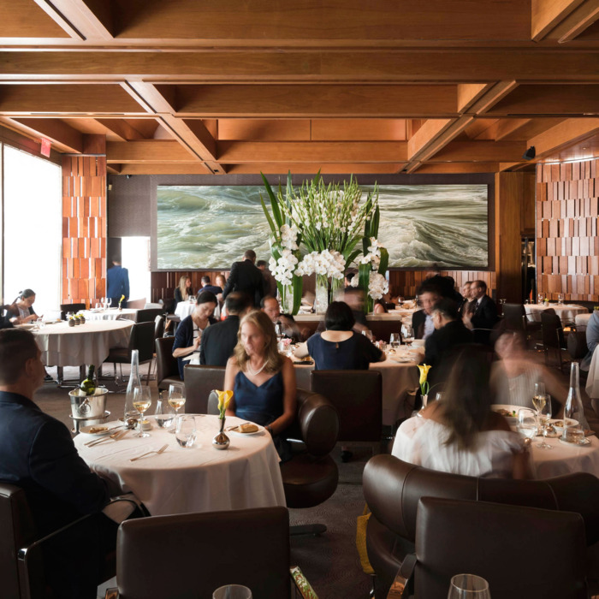

Restaurant Order App

Team restaurant

# Vlad Vatsurin | Nathaniel Fisher | Luis Villafana | Steven Caird

# **Project Overview**

The Restaurant Order App Project is aimed towards simplifying the interaction process within the waiter and the client in restaurants. With the Restaurant Order App, restaurant clients will have an option to skip waiter waiting moments and have an ability to make an order instantly using the mobile application.

The development environment for that project is XCode. The target platform is iOS smartphones (iPhone).

Technology used for the development is a Swift coding language.

## **Functional requirements**

Create Order

- made up of DISHes

- computed properties: items ordered, subtotal, tax, total

- inputs: items ordered

- outputs: subtotal, tax, total

Main

- in connection with Main view, provides overview of tables, total sales, and servers

- input: server login

- output: total sales, servers logged in

Pay Bill

View Menu by Category

View Menu Categories

Choose Table

## 

## **PROJECT DESIGN**

**Classes**

|  |
| --- |
| **Order (Bill)** |
| Properties: |
| items ordered-data structure that stores Item objects |
| subtotal-computed property |
| tax-computed property |
| total-computed property |
| Methods: |
| init |
| deinit |
| add item |
| remove item |

|  |
| --- |
| **Dish/Item** |
| Properties: |
| name |
| description |
| price |
| Methods: |
| init |
| deinit |

|  |
| --- |
| **Category** |
| Properties: |
| categoryName |
| Dishes - data structure containing data structure object |
| Methods: |
| init |
| deinit |

|  |
| --- |
| **Main** |
| Properties: |
| table |
| Methods: |
| makeOrder |

**Views**

* Main, Order/Bill, Menu 1 (with choice of categories) Menu 2 (1 for each category - this one contains dishes in each category)
* Possible addition of master view (phase 2)

## **WORK ASSIGNMENTS**

Classes

* Dish - Vlad
* Category - Luis
* Main - Steve
* Order/Bill - Nathaniel

Views

* Main - Steve
* Menu 1 (categories) - Luis
* Menu 2 (dishes in category) - Vlad
* Order/Bill - Nathaniel